

|  |
| --- |
| CGI506 Assessment 1-2 |
| Ikazuchi |
| Name: Rhylei Tremlett  ID: 13513865  Date: 5/11/2023 |

Table of Contents

Introduction………………………………………………………………………………………………………………………….2

Addon One……………………………………………………………………………………………………………………………2

Description 2

Usage 2

Implementation 2

Addon Two……………………………………………………………………………………………………………………………3

Description 3

Usage 3

Implementation 3

Addon Three…………………………………………………………………………………………………………………………4

Description 4

Usage 4

Implementation 4

Addon Four…………………………………………………………………………………………………………………………..5

Description 5

Usage 5

Implementation 5

Addon Five……………………………………………………………………………………………………………………………6

Description 6

Usage 6

Implementation 6

# Introduction

For this course we tasked to undertake a project to create a set of tools for a given CGI editing application that enhance the production workflow. This project consists of five tools; each tool and its requirements are documented within this document.

The purpose of this project and course is to gain an understanding of selecting and implementing a programming language to develop custom tools that facilitate a production scenario.

The name of this project is (romanised as ikazuchi), which is an archaic Japanese word for thunder and lightning. This project aims to create a collection of add-ons that help blender users quickly create environments with fully functioning weather and interactions.

The features that are being developed for this course are divided into separate add-ons and are as follows:

* A new workspace and a center view to object hotkey.
* Generate procedural clouds that change form as they move.
* Make a mesh into a rain emitter (pairs well with the clouds).
* Make any mesh interact with rain, with effects like waves/ripples and wet/dry.

To use these add-ons, they must be downloaded from the GitHub repository found [here](https://github.com/KyrVorga/CGI506-Project). They are installed like any other blender add-on through the blender preferences inside the addon tab. The only exception is loadup.py, which must be manually placed within the blender scripts/startup directory.

# Addon One

These scripts are to set up and clean up the environment and workspace in your selected editing technology.

Script A is to:

* Load and run when the editing environment is started.
* Select and present your work layout.
* Add any additional features you regularly use.

Script B is to:

* Load and run when the editing environment is closed and quit/exited.
* Clears any cache that your work has accumulated.
* Remove/add any additional features you have added in script A.

## Description

This add-on is a start-up script that creates a new workspace called ‘Minimal’ and registers the ‘Center View’ hotkey, which focuses the viewport on an object and resets the zoom level.

## Usage

The minimal workspace can be located in the workspace bar. By default, it will be next to the layout workspace.



Figure - Location of the minimal workspace.

Currently, the minimal workspace is a copy of the layout workspace due to unclear API documentation.

The Center View hotkey is bound to V; to use it, an object must be selected in a 3D viewport.

See Figure 2 and Figure 3 for a before and after comparison of using the Center View hotkey.

## Implementation

On startup of Blender, this script will register the CenterView class as an operator and bind its execute function to the V key within 3D viewports. When this key is pressed, the cursor is relocated to the selected object. Then, a built-in function is used to move the viewport to the cursor. Afterwards, the cursor is restored to its original location.

To create the minimal workspace, the script creates a copy of the layout workspace, renames it, and sets it as the active workspace.

# Addon Two

This script is to implement a button-like addition to the editing environment that can be used to enhance your ongoing work. For example, generate a 3D feature used in many places in your artwork.

You are to create two scripts that are:

* Both are added as a button to the workspace.
* Script A runs and implements the generation of a 3D feature or equivalent.
* Script B runs and implements the removal (delete) of a 3D feature or equivalent.

## Description

This add-on is called Apply Rain. As the name suggests, it creates a particle system on all selected meshes and configures it to emulate rain.

This add-on has two operators, one which applies the rain system and another which removes it. They are Apply Rain and Revert Rain, respectively.

## Usage

This add-on is used with the other add-ons to create weather within a scene.

To use this add-on, any number of meshes must be selected and the operator executed. The result is all selected meshes become rain emitters.

The operator can be found within the add tab of the 3D viewport; see Figure 4.

The effects of the Apply Rain operator can be reverted with the Revert Rain operator at any time.

Apply Rain is best paired with the Generate Cloud operator. For example, take Figure 5, a cloud that has just been generated with the Generate Cloud operator. Once the Apply Rain operator is used on the cloud mesh (not the volume), it will result in Figure 6.

## Implementation

The first time the add-on is run within a scene, it creates a raindrop object and a rain material. All future particle systems use this raindrop as the object to be emitted.

The operator will iterate over every mesh selected in the outliner and create a new particle system for each mesh. This allows each one to be customised individually.

Each particle system is set to emit the raindrop object.

# Addon Three

This script implements a button-like addition to the editing environment that can be used to enhance your ongoing work with the computer file system. For example, move your work to a standard folder and rename files.

You are to create two scripts that are:

* Added as a button to the workspace.
* Script A moves files in your file system or equivalent.
* Script B renames files in your file system or equivalent.

## Description

This addon is called Backup and allows users to create timestamped backups in a folder of their choosing.

## Usage

Users can enter the file tab shown in Figure 7 and execute the backup operator. This will then prompt the user to select a location on their computer using the native file manager. This will result in the .blend file being backed up and dated within that location.

## Implementation

The Backup operator requires that the project is named, meaning it has been saved at least once. If this is the case, it calls the window_manager to prompt the user for a location. The operator will save, copy, relocate, and rename the file all in one go.

# Addon Four

These scripts are to move through the current artwork being edited to adjust objects in the artwork in your selected editing technology.

You are to write one script that traverses the object hierarchy to manipulate a feature of an object or object in your artwork.

This script is to:

* Select an object or set of objects from your object hierarchy.
* Adjust a feature of that object or the selected set of objects.
* Move an object or set of objects to a different place in the hierarchy.

## Description

This section consists of two add-ons that have similar functions. Each add-on has two operators: an applier and a reverter.

The first add-on is Apply Waves, which creates a dynamic canvas on all selected meshes. This canvas is configured as waves; this lets the rain particles create ripples on the mesh surface.

The second add-on is Apply Wet FX. It creates a dynamic canvas that is configured as paint. It also creates/modifies the mesh material to use the canvases wetmap to change how light interacts on the surface of the mesh.

## Usage

These operators can be applied to any mesh to let it interact with the particle systems created by Apply Rain.

The operators are in the add tab, as shown in Figure 4.

The effects of the Apply Waves operator are shown in Figure 8.

The effects of the Apply Wet FX operator are shown in both Figure 9 and Figure 10.

## Implementation

Both Waves and Wet create a dynamic canvas receptive to particle systems. In the Wet FX operator, modifications are made to the mesh’s current material to integrate the canvases wetmap.

# Addon Five

This script is to implement procedural generation or interaction within an artwork. For example, generate a whole work based on a set of 3D features.

You are required to create one script that:

* Generates a complete artwork.
* Runs and implements the generation of one form of 3D feature (or interaction) or equivalent.
* Runs and implements the generation of a 3D feature (or interaction) different from the one implemented for requirement two or equivalent.

## Description

The final add-on in this project is named Generate Cloud. It has this name because it uses randomness to procedurally generate a new cloud each time.

## Usage

The operator can be found with the others in the add tab shown in Figure 4.

This operator doesn’t require anything to be selected. The operator, when executed, will generate a new cloud at the location of the cursor.

A newly generated cloud will look as shown in Figure 5. Once the cloud mesh is hidden and the renderer is set to use cycles instead of Eevee, it will result in whats shown in Figure 6.

## Implementation

The clouds are made using a mesh, which is displaced and deformed into a cloud-like shape, and then a volume is added and bound to the mesh. The volume is then given a mesh-to-volume, which fills the shape of the cloud mesh with fog.

The volume is then displaced using a cloud noise texture to provide more randomness to the cloud. The cloud's texture is bound to an anchor, which is placed in the centre of the world space; this means that when the cloud is transformed through space, it will change shape.

The cloud mesh and volume are created within a collection. This collection is given a unique hex identifier.

The cloud mesh is intended to be hidden, but due to limitations in the Blender py API, it must be hidden by the user.

A movement anchor is created in each cloud collection; this is an empty object. The location of the cloud volume is bound to the cloud mesh, which in turn is bound to the movement anchor; this allows it to be dragged around the viewport.

Appendix

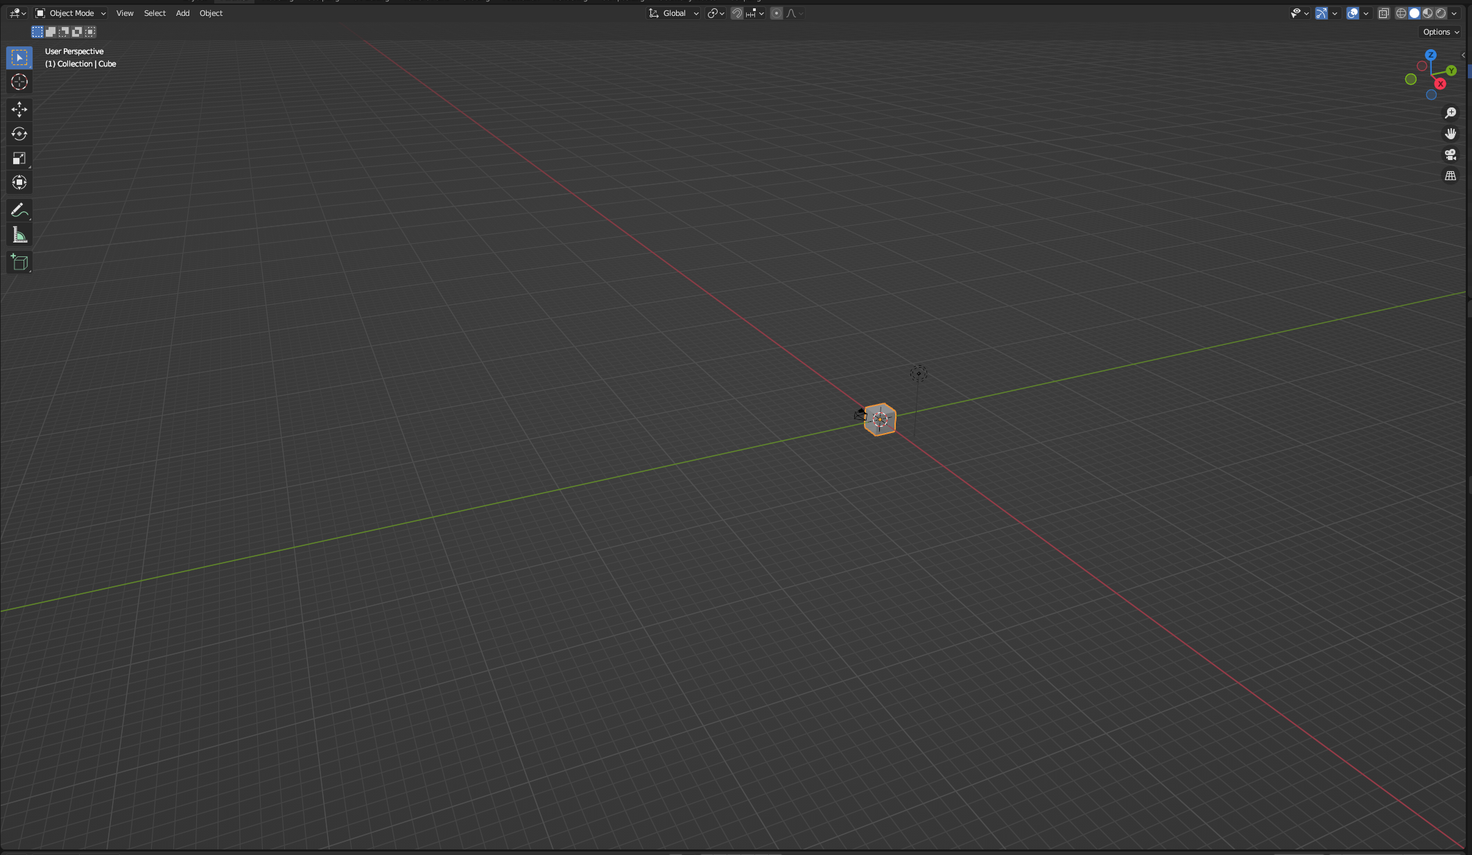

Figure - Blender viewport zoomed out and panned away.

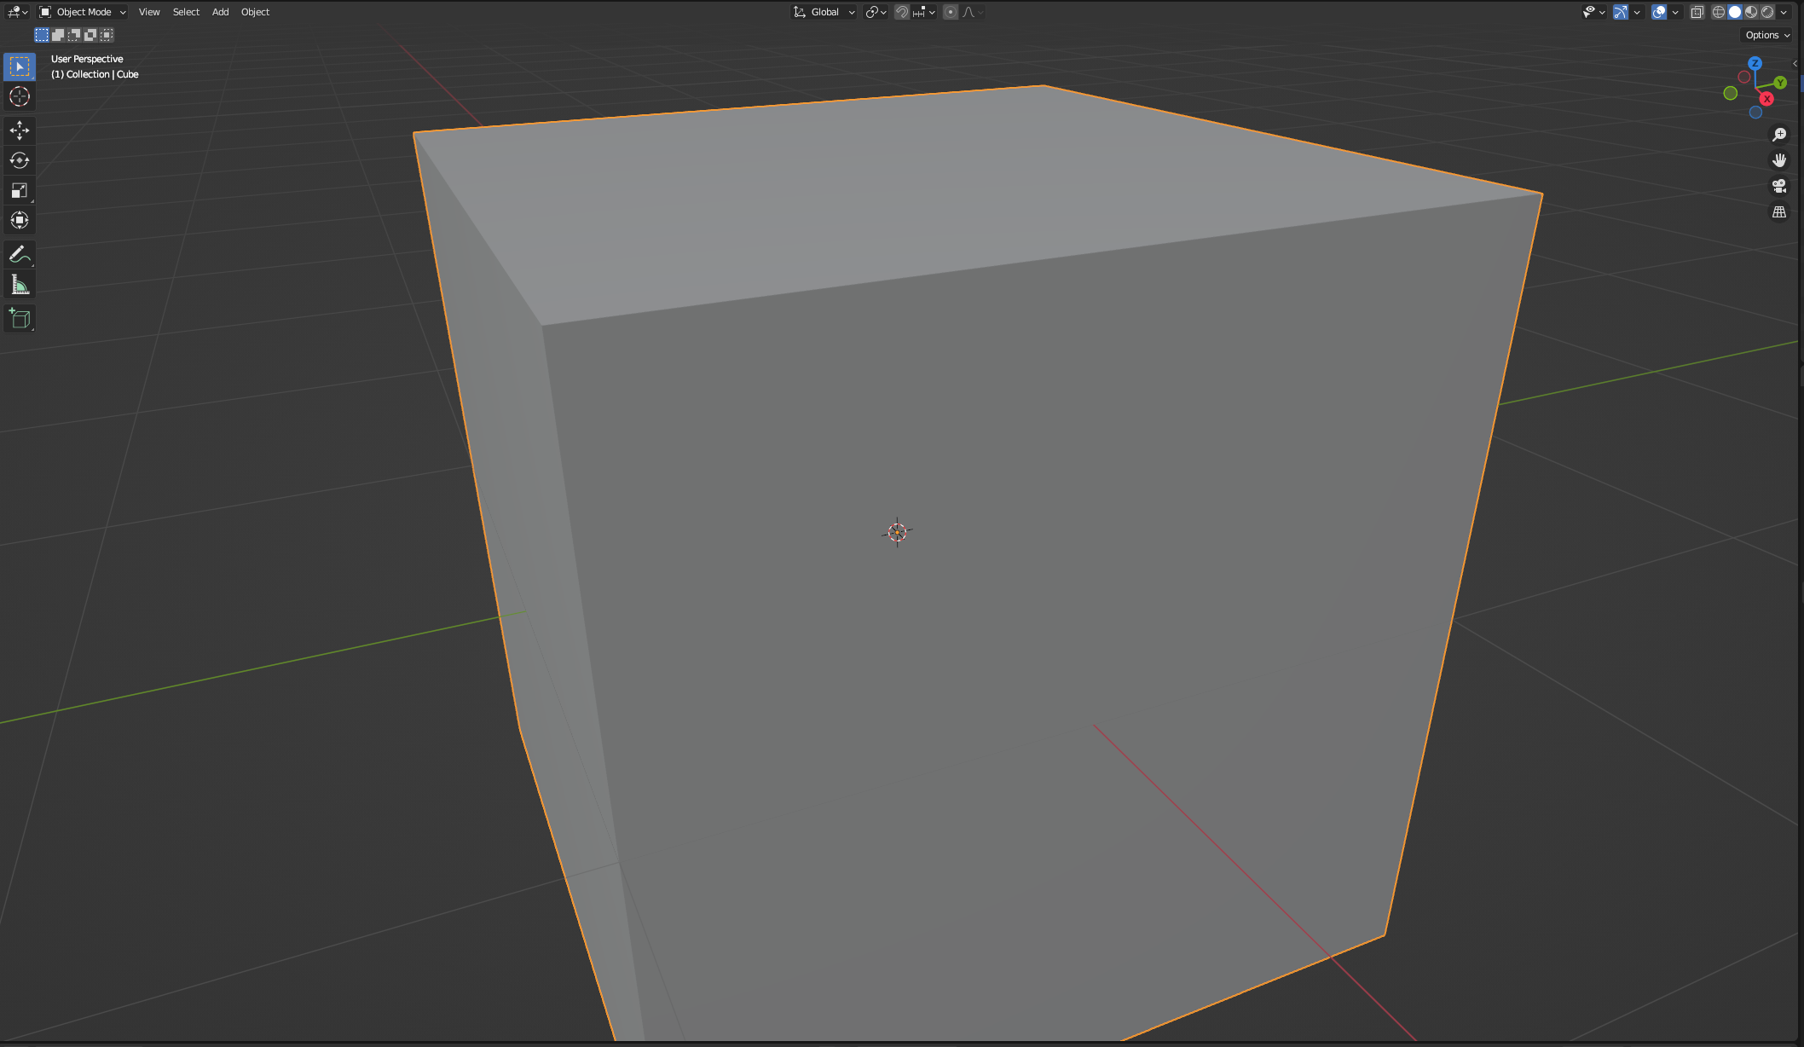

Figure - Blender viewport after using the center view hotkey.

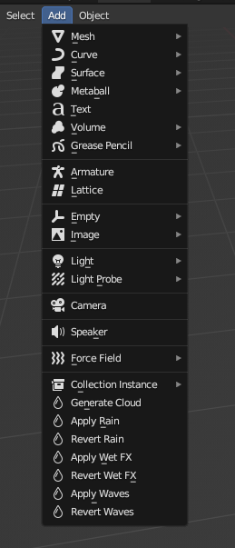

Figure - The location of the Ikazuchi operators within Blender.

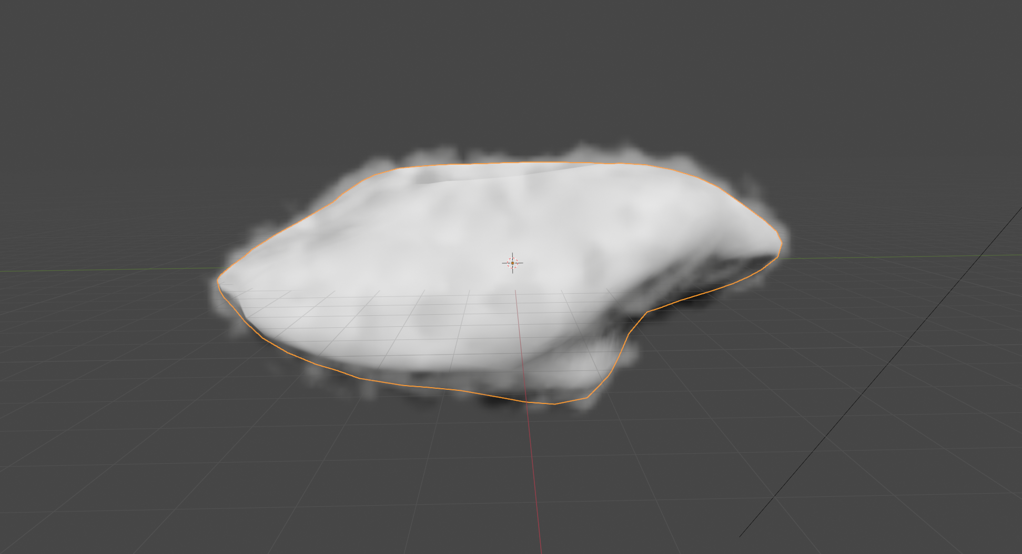

Figure - A cloud within blender that has just been generated.

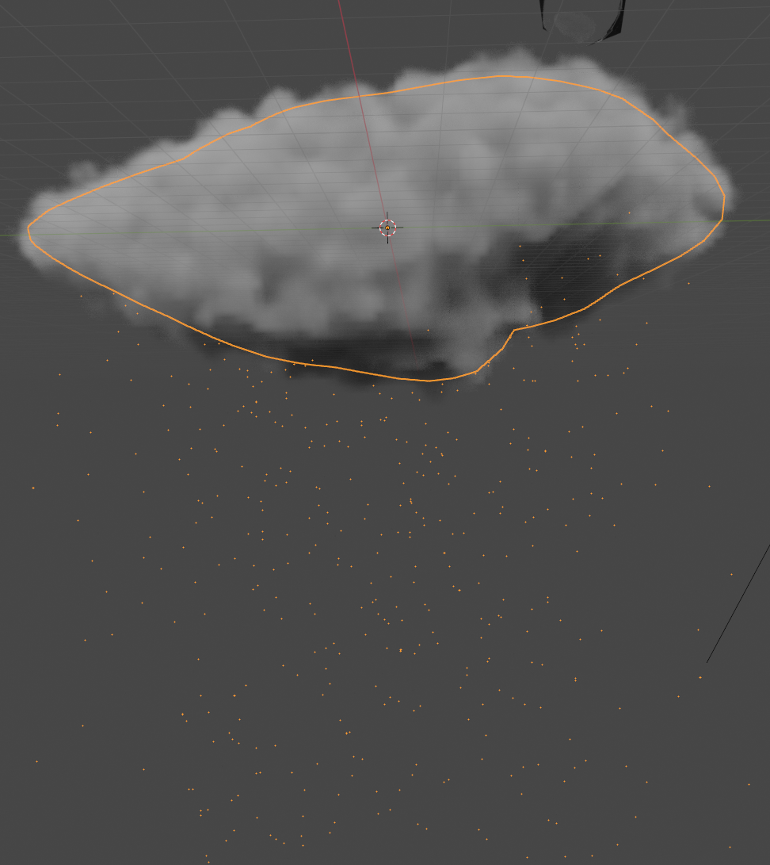

Figure - A rain cloud with falling rain.

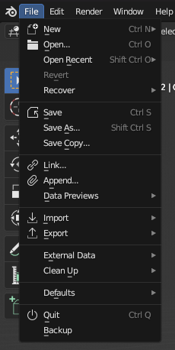

Figure - The location of the Backup operator.

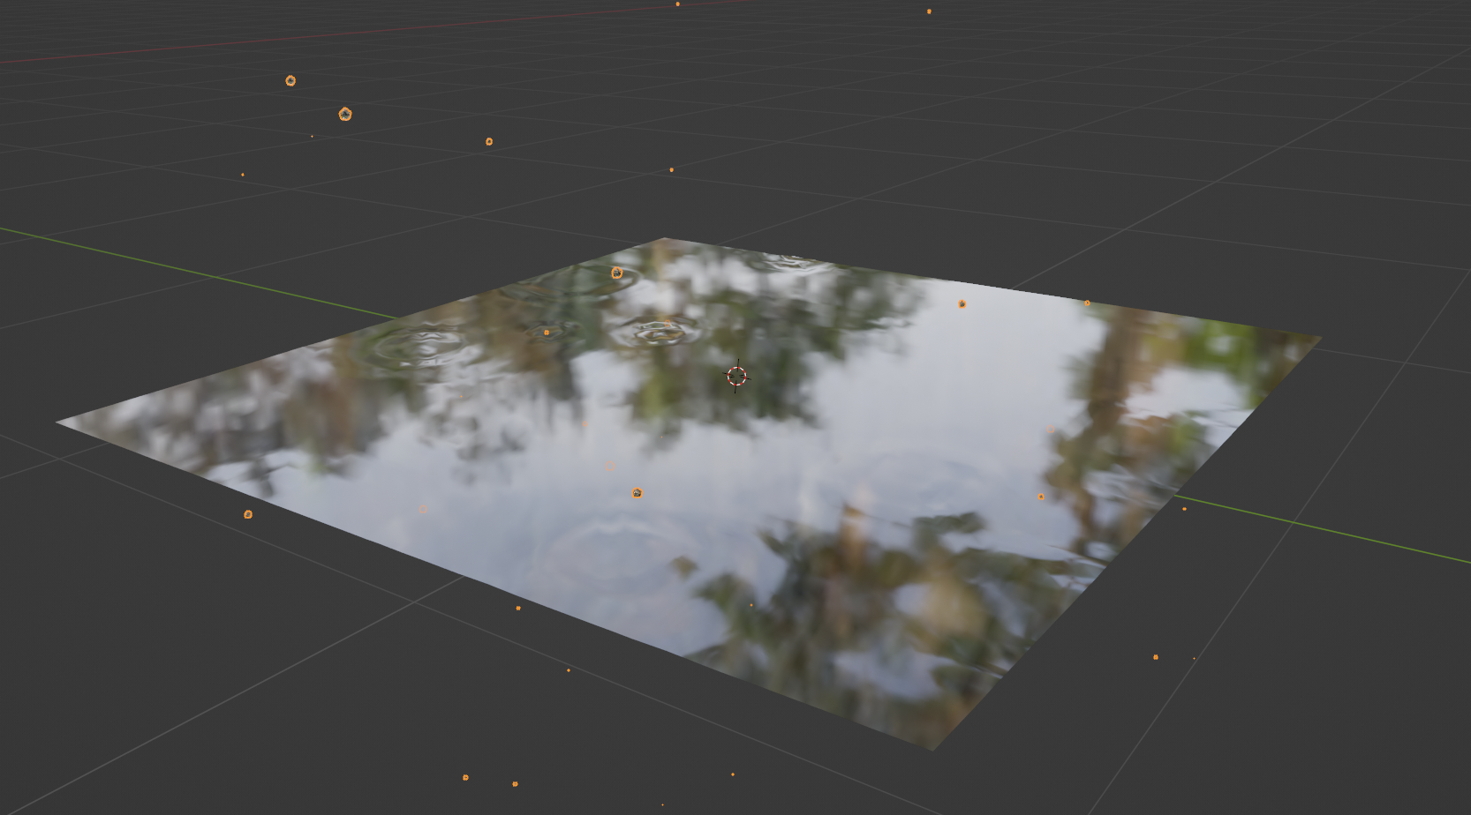

Figure - A simple example of the Apply Waves operator.

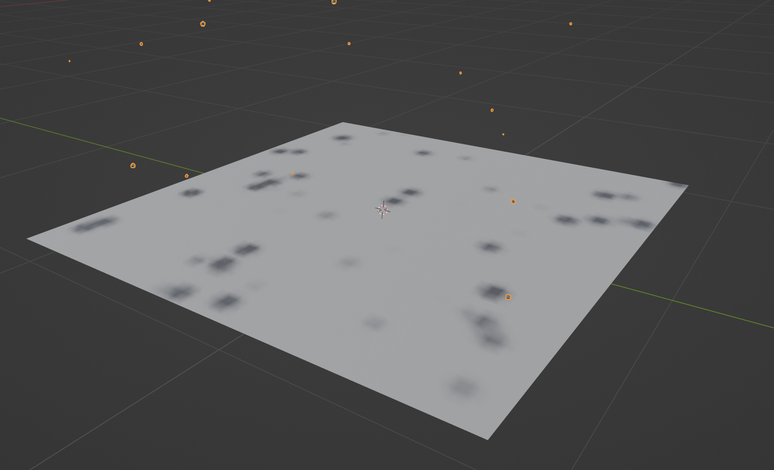

Figure - A crude example of the Apply Wet FX operator without an textures.

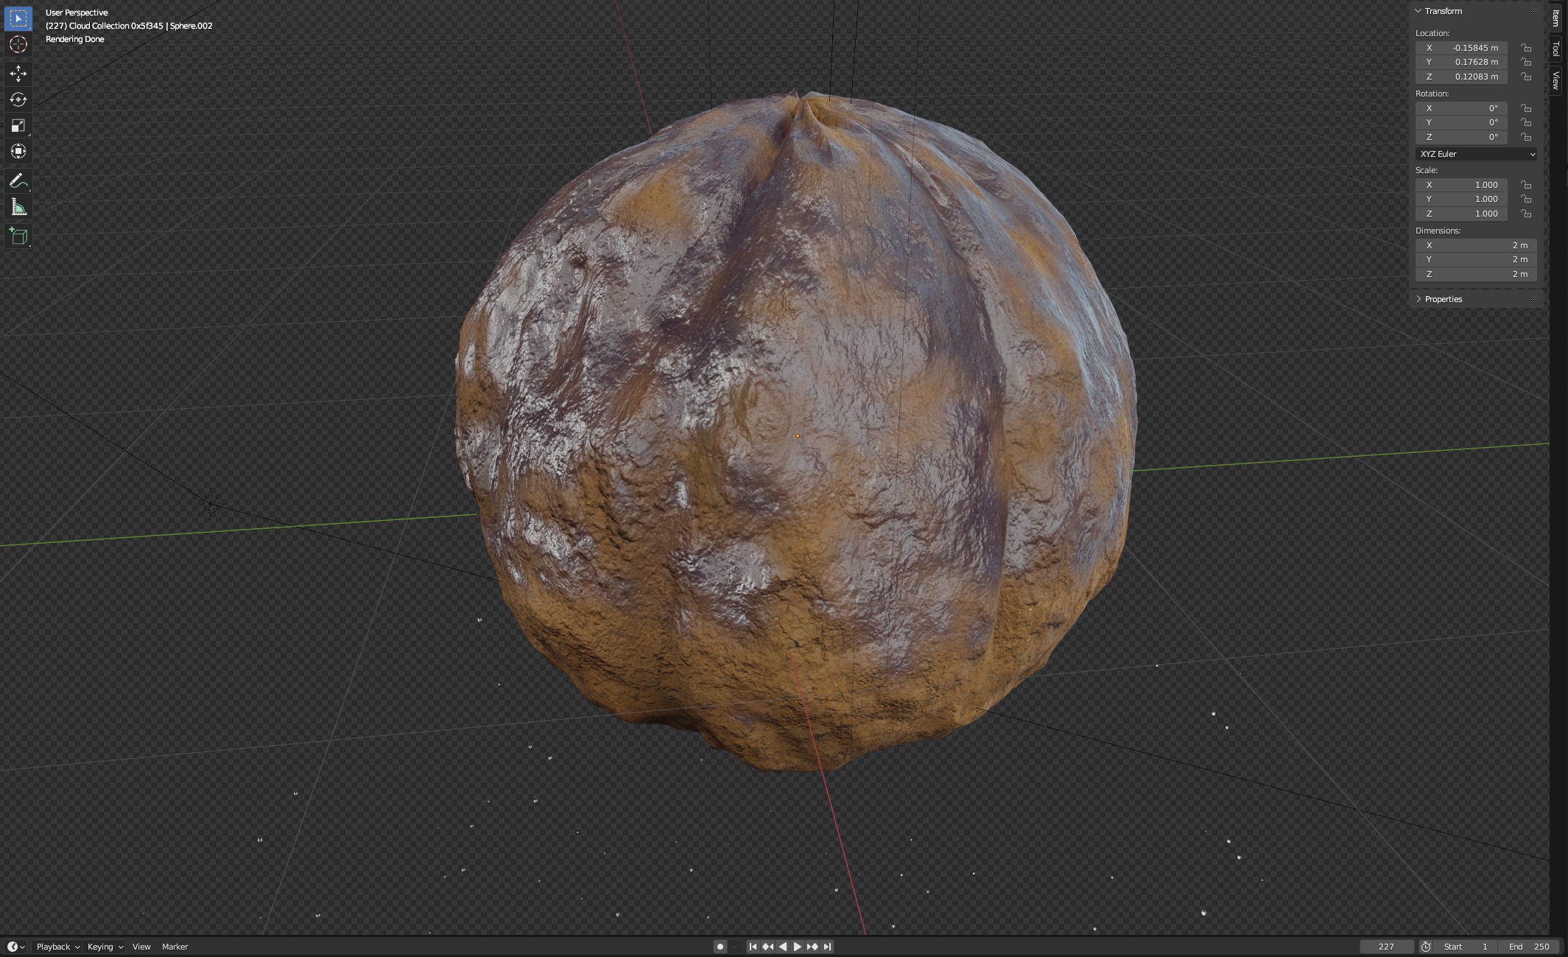

Figure - A better example of the Apply Wet FX on a textured dirt ball.